Machine Learning for Network Analysis Exercise

## Objective

Investigate Clustering approaches from machine learning to analyze network behavior

## Instructions

Please watch *Machine Learning for Network Analysis* video. Then, complete the following four prompts:

1. Using the following figure and its labeled coordinates (X1, X2, Y1, and Y2), please provide the equations for Euclidean and Manhattan distances, respectively.

Note that you may go to “Insert”-->”Equation” in Microsoft Word to help type your answers. You may also choose to write “sqrt” to mean square root.

The Euclidean distance is shown as a direct line between the points, while the Manhattan distance is represented by two perpendicular dashed lines, first moving horizontally from 
X1 to X2 and then vertically from Y1 to Y2.

Euclidean = $sqrt$ $({X2-X1)}^{2}+{(Y2-Y1)}^{2}$

___________________________

Manhattan = $|X2-X1| +|Y2-Y1|$

___________________________

1. Using the preceding figure, please provide the actual Euclidean and Manhattan distances, respectively.

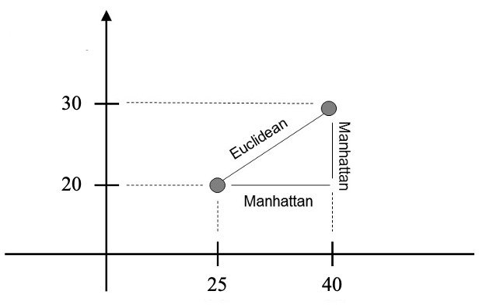

Euclidean = _________18.027 Unit__________________

Manhattan = ____25Unit_______________________

3. Calculate degree and closeness for each of the nodes in the following graph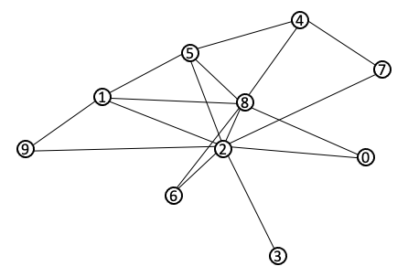

|  |  |  |  |
| --- | --- | --- | --- |
| Node | Degree | Closeness | Betweenness |
| 0 | 2 | 0.529 | 0.000 |
| 1 | 4 | 0.600 | 0.056 |
| 2 | 7 | 0.750 | 0.403 |
| 3 | 1 | 0.450 | 0.000 |
| 4 | 3 | 0.529 | 0.222 |
| 5 | 4 | 0.643 | 0.111 |
| 6 | 2 | 0.529 | 0.000 |
| 7 | 1 | 0.360 | 0.000 |
| 8 | 6 | 0.750 | 0.292 |
| 9 | 2 | 0.474 | 0.000 |

1. Draw your own personal “social network” and then remove your node from the network. After removing your node, which nodes rank highest in degree and closeness?